**Development of an Open Source Data Acquisition System for the SmartFarm Platform**

Bo Liu1*, Caleb Fink1, Nathan Oto1, Chandra Krintz2, Rich Wolski2, Balaji Sethuramasamyraja3

1 Dept. of BioResource and Agricultural Engineering Cal Poly State University, San Luis Obispo, US, 2 Dept. of Computer Science UC Santa Barbara, US; 3 Dept. of Industrial Technology, Fresno State University, US

## 

## *Abstract:* This paper describes the development of an open-source data acquisition (DAQ) system for the SmartFarm platform. The hardware provides protection for measurement circuits, a real-time clock module, onboard data storage, various wireless communication protocols support, a wide range of agricultural sensor supports, and an on-farm gateway. The custom firmware on the circuit board allows minimal power consumption, automatic sensor identification and data reading, enables easy data capture, storage, and wireless transmission. In addition, the web-based user interface enables online drag-and-drop wireless programming and text-based programming. This paper also demonstrates an example of soil moisture data collection using the developed system. The experimental result shows that this DAQ system can be easily configured and reliably measure data, and it is suitable for environmental measurements, and provide data for the cloud-based SmartFarm decision support system.

*Keywords:* SmartFarm*,* Decision Support System; Data acquisition system; Open source; Wireless sensor network

# 

# **1. Introduction**

The agriculture industry faces tremendous pressure to feed 10 billion people by 2050. This problem is compounded by severely limited natural resources, the requirement of sustainability, and climate change, and other unpredictable variables. Farmers are increasingly turning to production measurement, monitoring, and data analysis to improve farm productivity and efficiency. Computing systems can automate the decision support process to facilitate faster problem diagnosis, more accurate outcome prediction, and proactive decision-making (Giordano et al.; Reddy and Rao; Marcomini, Suter II and Critto). At the same time, individual growers and ranchers are underserved by many recent advances in computing that make data analytics consumable as simple end-user products. Current decision support offerings for these constituencies are variously limited, proprietary, complex, and costly, requiring that farmers give up control of their data (Minae, Baker and Dixon; Tham-Agyekum; Giordano et al.). To address this problem and to overcome these challenges, the authors have introduced the SmartFarm platform (Krintz et al.) which integrates agricultural sensor technologies into an on-farm, private cloud software infrastructure which gives farmers a secure, easy-to-use data analysis and decision support system. It also provides an interface which custom analytics apps can be plugged into, and ensures that all private data remain under growers’ control (Krintz et al.). The schematic diagram of the SmartFarm system is shown in Fig. 1. To collect reliable farm sensor data for the SmartFarm data analysis and decision support system, a versatile and rugged DAQ system is needed.

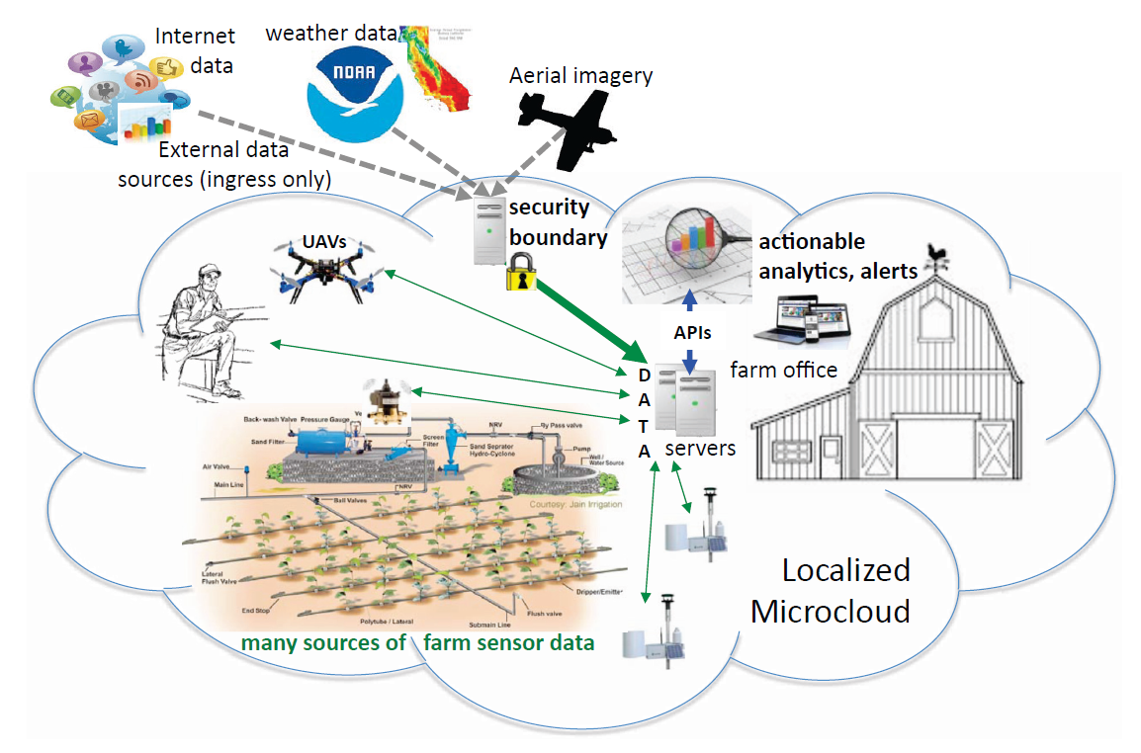

Fig. 1. Schematic diagram of the SmartFarm platform (Krintz et al.)

There are many different data acquisition technologies and systems that have been developed for agriculture. Amiama et al. (2008) introduced a data acquisition system with positioning sensing and a communication module on a harvester. The data could be transferred manually from the mobile equipment to the cooperative's control center by short message service. Nkom and Musa (2009) designed a PIC 16F628A microcontroller-based digital data logger which can sense TTL logic level transitions on a designated data logging input and attach a time stamp to the measured signal. Watthanawisuth et al. (2009) implemented micro-climate real-time monitoring based on ZigBee wireless sensor network and the system was installed and tested in a vineyard. We have examined the stability and durability of the devices and system for 12 months. The microclimate data was transmitted wirelessly and stored in PC for further analysis by the farmers. In recent years, some researchers have tried to integrate open source, low-cost microcontroller-based measurement systems for environmental monitoring. Baker (2014) incorporated real-time environmental monitoring using low-power and low-cost Arduino microcontroller platform. The battery-powered data logger can record temperature and humidity on a micro-SD card and a server. Mesas-Carrascosa et al. (2015) developed an Arduino based a device that records environmental parameters and a smartphone software that links the data acquisition system to a data server to process and analyze the information.

Most of these available agricultural data acquisition systems only take certain specific sensors, require programming knowledge, and lack data analysis and decision support. Therefore, we propose an open-source, versatile, plug-and-play and rugged wireless DAQ system for the SmartFarm platform to collect, store and transmit environmental data for further data analysis and SmartFarm decision support system development.

# **2. Data Acquisition System Design**

The SmartFarm DAQ system is designed to take sensor measurements and send data wirelessly to a base station and post data to the cloud for data analysis and decision support, as shown in Fig. 2. The SmartFarm DAQ hardware features a low-cost, energy-efficient, flexible I/O integration for various agricultural sensors, multiple communication protocols support, and an open source hardware system. The SmartFarm DAQ software includes a firmware to run on a microcontroller and a drag-and-drop web-based programming user interface.

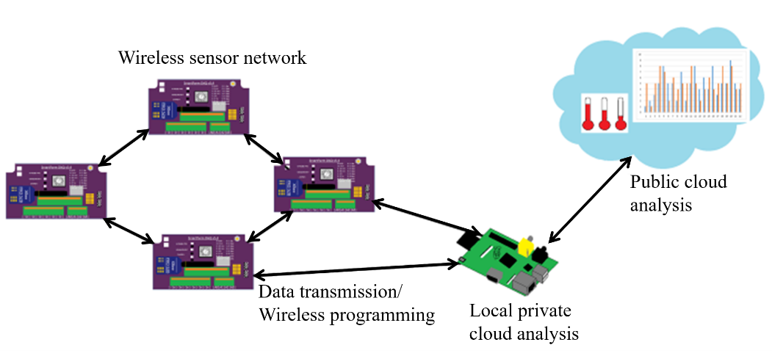

# Fig. 2. Data acquisition system diagram

**2.1 Hardware design**

The DAQ circuit board is equipped with two Atmel® AVR® 8-bit ATmega328p microcontrollers. One of them acts as the controller which controls power sources of all the circuits on the board, sleep scheduling, over-the-air programming, and the other microcontroller is used to take sensor data and store/transmit data. The onboard micro-SD card can be used to store backup sensor data. Various wireless modules can be connected to the board to send data to the on-farm base station and wirelessly program the DAQ microcontroller if needed. The DAQ wireless module is designed with XBee® radio footpad and has been tested to work with XBee series 1, 2, and 3 radios, Wi-Fi and LoRa® modules. There is a real-time clock (RTC) module onboard which gives timestamps of all the measurements. The solar charge controller can charge a one-cell Li-on battery using a solar panel to power the entire circuit. The overview circuitry of SmartFarm DAQ board is shown in Figure 3.

# *Controller microcontroller circuit*

The programmer is connected to a 16-bit rotary encoder which is used as a sleep timer. The timer provides the user with a manual sleep time selection between 5 minutes to 2 weeks or with the option of a radio self-controlled sleeping mode. This sleep time is the time interval between data acquisition periods. The indicator LED indicates which mode (measurement mode, sleeping mode or wireless programming mode) the board is currently in. The controller also controls the signals going to the power control circuits for the entire circuit board. Each functional circuit (sensors for example) can be turned on or off to save power. The circuit diagram of the controller is shown in Fig. 4.

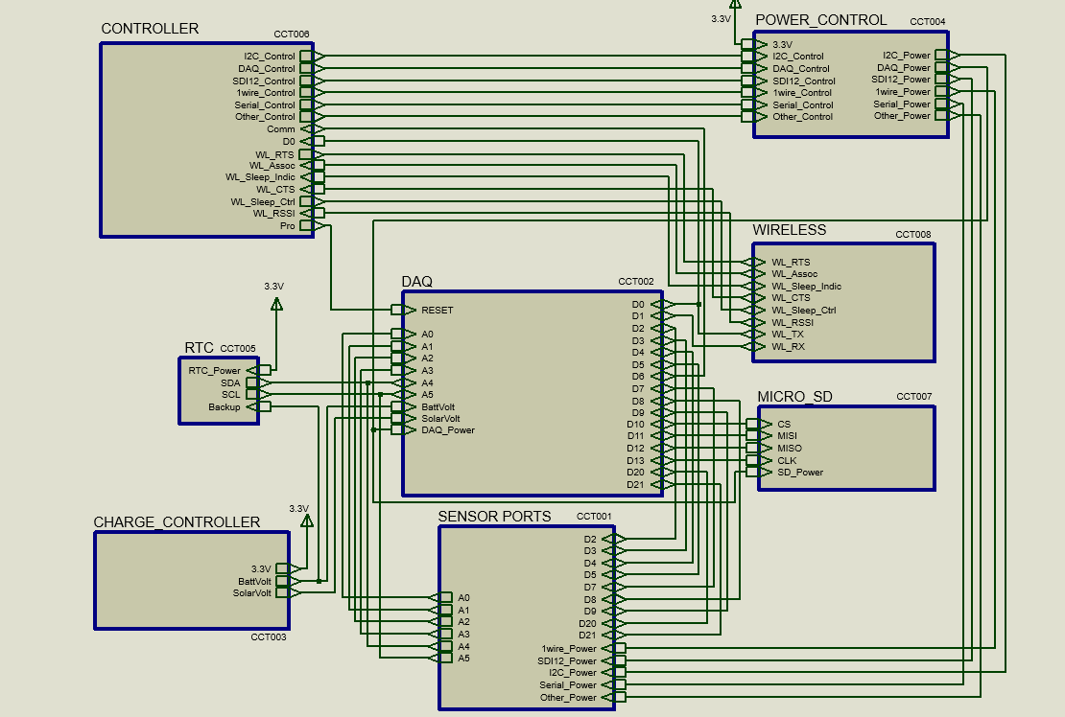

Fig. 3. Overview circuitry of the SmartFarm DAQ board

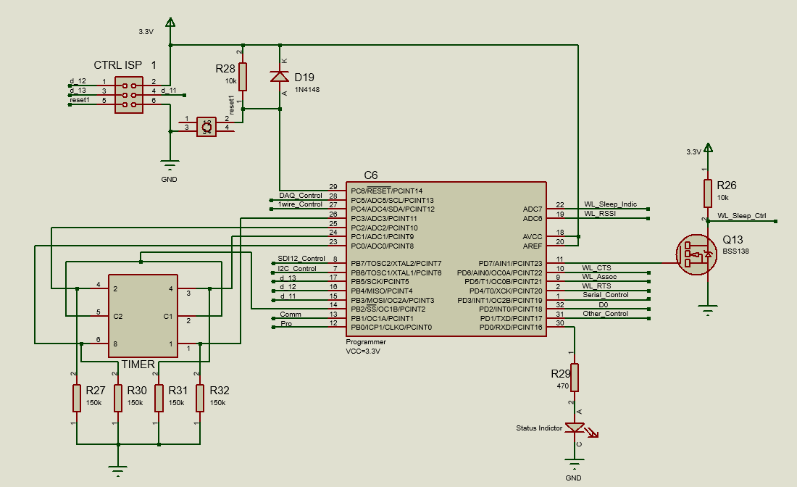

Fig. 4. Controller circuit diagram

# *DAQ microcontroller circuit*

The DAQ microcontroller is used to take measurements from sensors, monitor the solar panel voltage and the rechargeable battery voltage levels. The DAQ chip supports I2C, Serial, SPI, analog voltage/current measurement, SDI12, and 1Wire sensors. For Watermark® SS200 sensors, the board has a built-in AC excitation circuit to power eight sensors using a 74HC4051 mux chip. All I/O pins of the microcontroller are protected with resettable thermo-fuses for overcurrent protection, and 3.3V Zener diodes for overvoltage protection. The circuit diagram of the DAQ circuit is shown in Fig. 5.

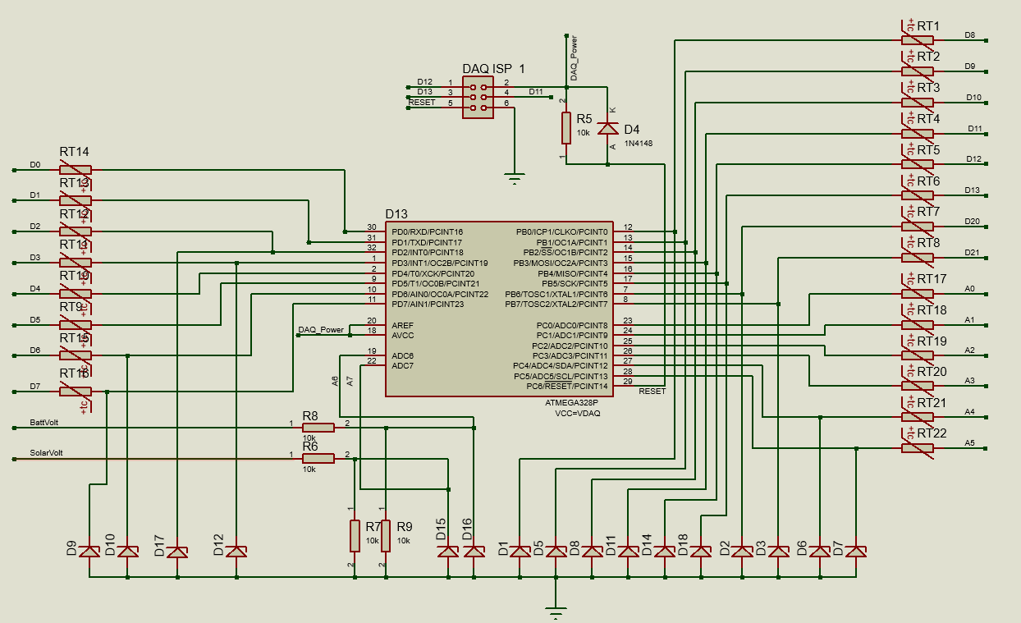

Fig. 5. DAQ microcontroller circuit diagram

# *Power Control Circuit*

The controller microcontroller manages the power of all the circuits through a transistor-transistor pair circuit. The power control circuit utilizes MOSFETs and NPN transistors to control the power of sensors and the DAQ chip (shown in Fig. 6). When the DAQ board is in the measurement and data transmission mode (depending on the number of sensors, sensor types, and wireless modules), it draws 37 mA to 250 mA, approximately 3.8 mA in the standby mode, and 1.3 mA in the sleep mode.

# *Charge Controller Circuit*

The charge control circuit manages the power system of the DAQ board. An MCP73831 Li-ion, Li-polymer charge management controller, is used to charge a single-cell 3.7v Li-ion battery using a 5V solar panel. The 3.3V switching voltage regulator maintains 3.3V to power the entire circuit board (shown in Fig. 7).

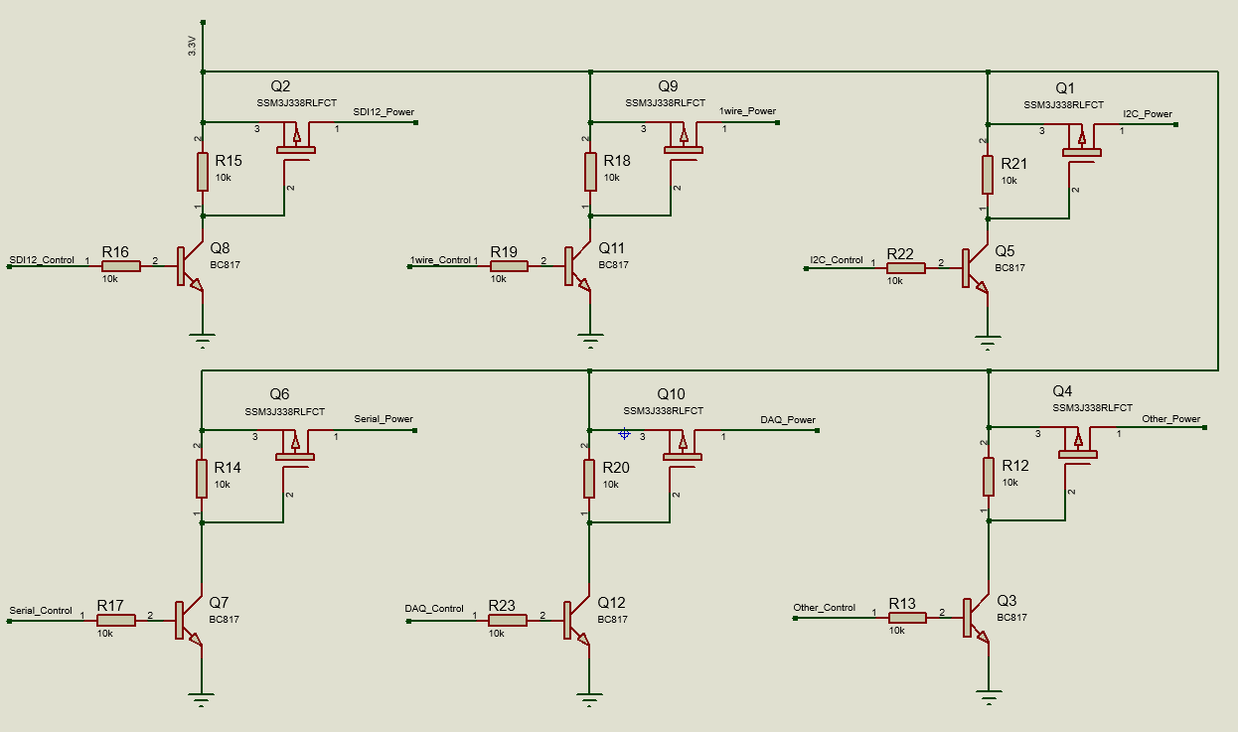

Fig. 6. Power control circuit

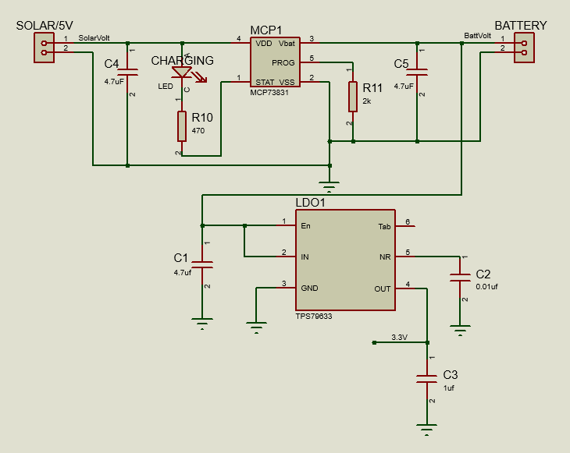

Fig. 7. Charge controller circuit

The printed circuit board design is shown in Fig. 8, and the final manufactured circuit board is shown in Fig. 9. Surface mount electronic components are chosen to reduce the board size, and screwless terminal blocks are used to connect sensor leads. The enclosure is waterproof and has a clear cover that protects the solar panel and the circuit board.

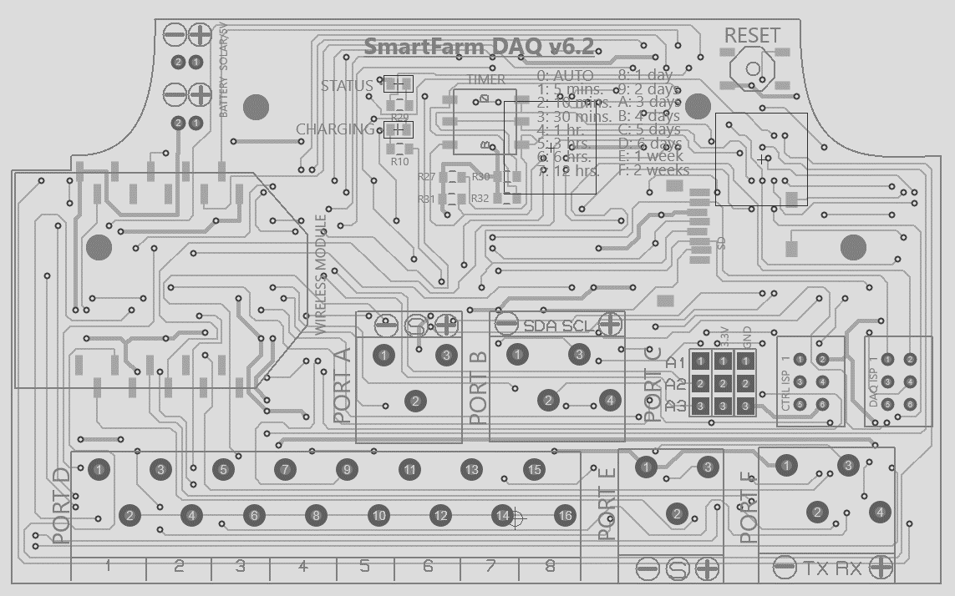 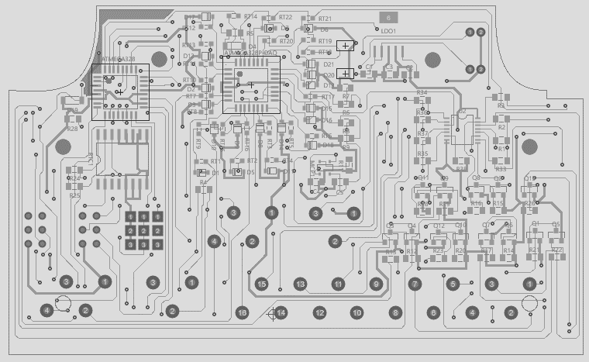

a) b)

Fig. 8. Printed circuit board design. a) top side, b) bottom side

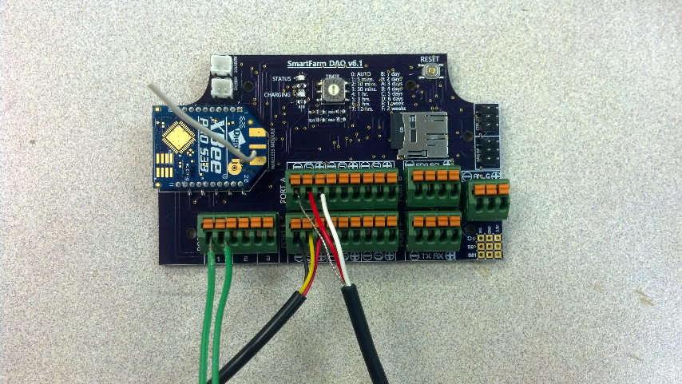

Fig. 9. SmartFarm DAQ circuit board

**2.2 Software design**

The DAQ software is consist of two main parts – the DAQ firmware and the web-based user interface. The firmware controls sensor data collection, sleep scheduling, power management, over-the-air firmware updates. The web-based user interface is used to program the DAQ boards over-the-air, and it also can be used to show DAQ board status.

# *DAQ board firmware*

The firmware creates an autonomous software that robustly collects environment data from the SmartFarm DAQ board. The library is designed to be plug-and-play, so it has the functions to scan all available sensors connected to each of the sensor port and read data automatically without further programming. The library also contains functions for ease-of-use, upon users’ desire of creating their programs for interfacing with the DAQ board. The DAQ board firmware flowchart is shown in Fig. 10. The library is written in C++, and it is compatible with Arduino C. Users can use or modify the library for advanced functions.

# *Web-based user interface*

The SmartFarm base station is designed using a Raspberry Pi, which is a very small form-factor computer. The Raspberry Pi 3 was utilized to develop the base station which is designed to perform as a gateway for the public cloud-based decision support system or a private cloud hosting machine. The base station posts measurement data from the SmartFarm DAQ nodes to the cloud with user inputs, and wirelessly programs the board via the wireless network as needed. A SmartFarm base station website was created, which allows the user to easily program the SmartFarm DAQ board from the site. To program the DAQ board using the web-based user interface, users can access the base station website where the integrated development environment (IDE) appears. There are three ways to program the board wirelessly. First, users can use the drag-and-drop programming interface to select the sensors to use and drop them to the corresponding sensor ports to finish the programming process. This method eliminates the text-based programming and makes the programming processing fast and easy. There is no programming knowledge required in this process. Second, users can also upload a program file (.txt and .ino file compatible) to the site. The base station will compile it and upload it to the DAQ board wirelessly when the board wakes up from a sleep cycle. The Python script on the base station receives a trigger command from the node and uses a C compiler to compile and upload the new program to the board. Finally, users can also choose to program the board using C++ (Arduino C compatible) in the web interface, this method gives users more control of the board settings and functions, but requires some programming knowledge and skills. The developed web IDE is shown in Fig. 11.

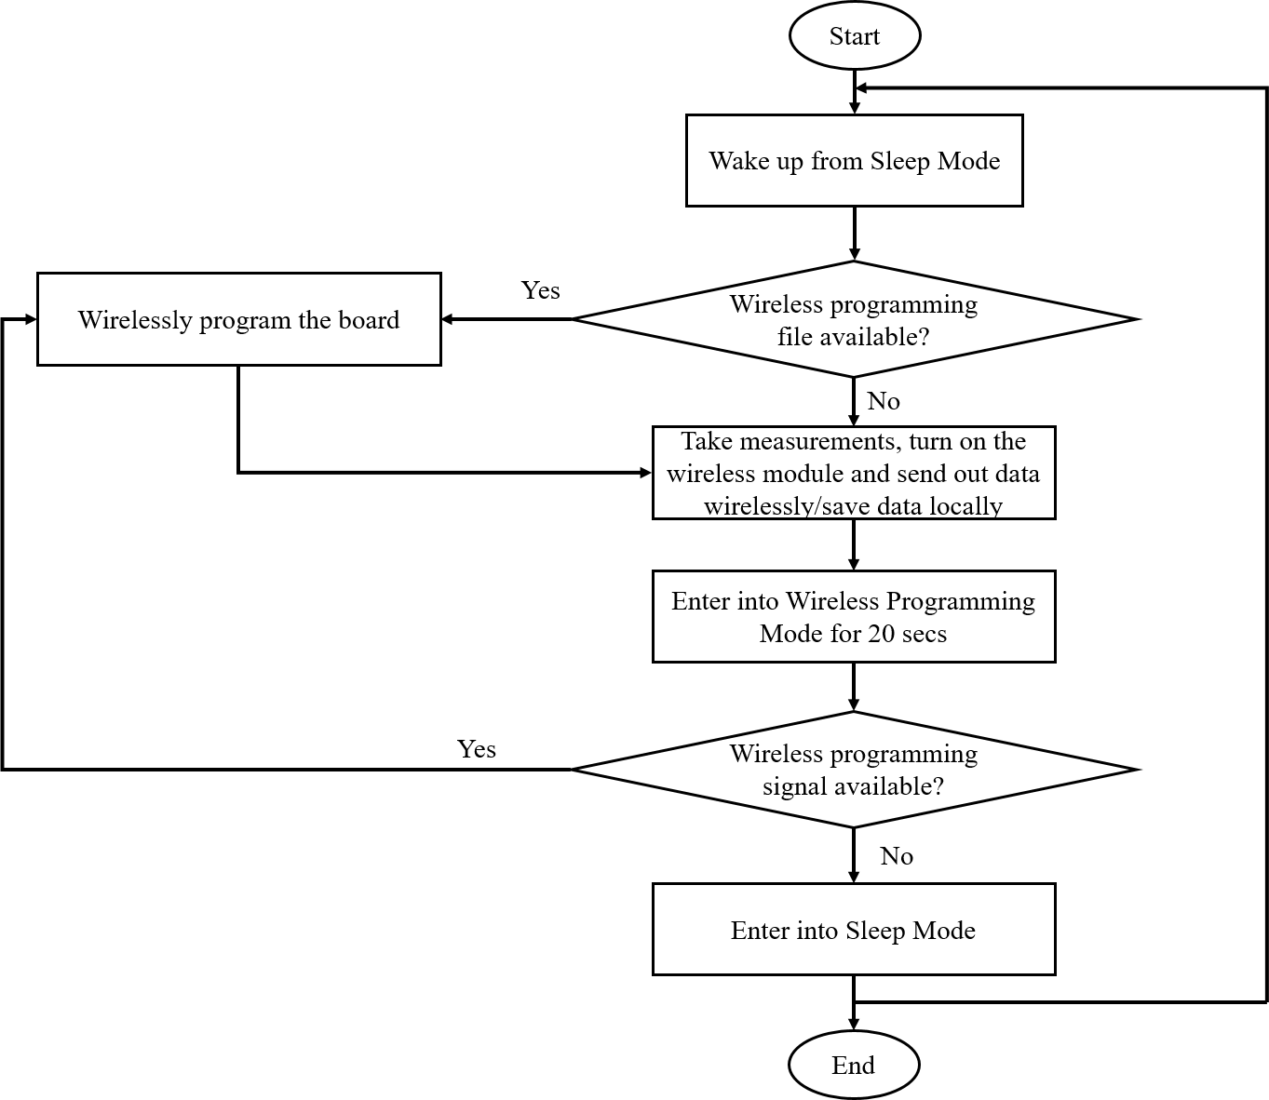

Fig. 10. Programmer firmware flowchart

 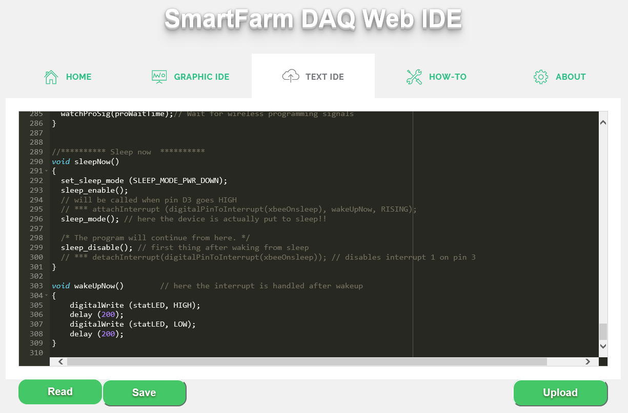

a) drag-and-drop graphic programming interface b) script based programming interface

Fig. 11. SmartFarm DAQ web user interface

**3. Experimental results and discussion**

To test the developed DAQ system, we deployed the system at the Student Experimental Farm (GPS coordinates: 35.3102236, -120.6730755) of California Polytechnic State University, and used it to collect soil water content and soil temperature data in two weeks. Watermark® SS200 sensors were used and inserted into ¾” PVC pipes to protect wires. They were soaked in irrigation water overnight, air dried for one day, and then re-soaked overnight prior to installation. Three Watermark® SS200 moisture sensors and three DS18B20 digital temperature sensors were buried at one foot, two feet, and three feet depths beneath the soil and the hole was backfilled with soil slurry. The final field experiment setup is shown in Fig. 12. The DAQ was wirelessly programmed through XBee ® series 3 Digi mesh network using the developed web user interface, and data was collected at a one-hour interval.

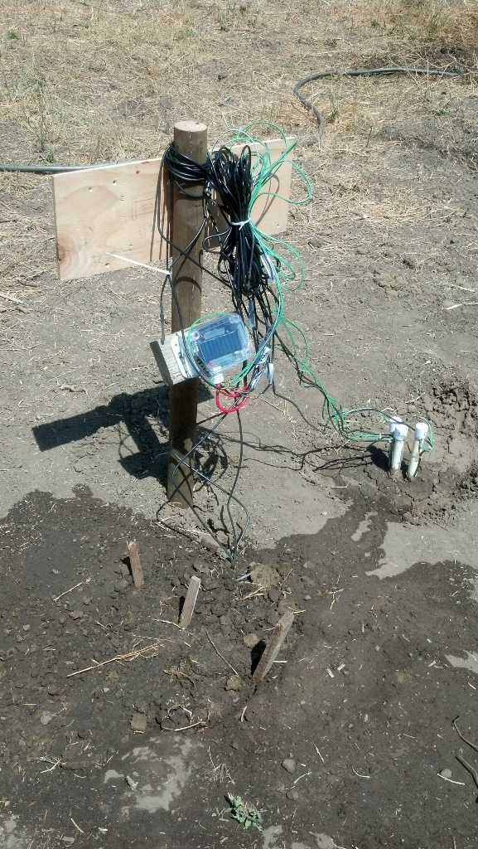

Fig. 12. Field deployment of the DAQ system

Soil moisture data was measured and transmitted by the developed DAQ system over two weeks. The DAQ board converts the output of the SS200 sensors from resistance (kΩ) to soil suction (kPa) based on the non-linear equation developed by Shock (1998):

*SMP* = (4.093+(3.213\**R*))/(1-(0.009733\**R*)-(0.01205\**Ts*)) Eq. 1

where *SMP* is the soil matrix potential in kPa, *R* is the sensor resistance in kΩ, and *Ts* is the measured soil temperature in Celsius near the SS200 probe. Fig. 13 shows the obtained soil moisture data at three depths over time. A lower soil matrix potential means wetter soil. A greater soil matrix potential means drier soil. A rise in the soil matrix potential indicates the soil lost moisture. A dip in the soil matrix potential indicates the soil gained moisture. A major drop in soil matrix potential indicates a significant watering event such as irrigation or rain.

Three irrigations were carried out to water the field where the sensors were installed (day 5, day 7, and day 14). Following the 3ft sensor data curve, the sensor indicates drying soil until an irrigation event at approximately 100 hours occurs. The 3ft sensors potential drops to about 7kPa before drying to about 12kPa at about 160 hours where the second irrigation event occurs. The third irrigation event occurs at nearly 335 hours dropping the readings from about 10kPa to 7kPa. The irrigation events can be seen in all three sensors at their respective depths. The 1ft and 2ft sensors gave similar readings of soil matrix potential. This indicates that the moisture in the soil was relatively constant from 1ft depth to 2-ft depth, and the 3ft depth soil contained less moisture.

Fig. 13. Soil matrix potential

# **4. Conclusions**

An open source wireless data acquisition system for dedicated agricultural real-time measurement has been developed. The system can be in conjunction with most agricultural sensors and common wireless communication protocols. The custom instrumentation software can automatically identify connected sensors and send out data to the gateway wirelessly. The device can be wirelessly programmed via a web-based programming interface. The field experiment shows that all the developed functions work, and data can be reliably collected and stored for further data analysis and decision-making. In conclusion, the developed DAQ system proves to be a reliable solution to support the cloud-based SmartFarm decision support system. Further work is still needed to support more agricultural sensors. The SmartFarm DAQ system design allows for installation of a dense population of agricultural sensors in any field. The cost of the DAQ hardware system is around 50 dollars without sensors and radios. In the configuration used for this study, the cost of the system was approximately 175 dollars. The life of the hardware is expected to last about ten years. It is expected that a commercial instrument will be produced and reported upon in the coming months, users can make their SmartFarm DAQ boards since both the software and hardware are open source.

# **Acknowledgements**

This research is partially supported by National Science Foundation [grant number 1539570], and CSU Agriculture Research Institute [grant number 16-03-021].

# **References**

Baker, Mr Ed. "Open Source Data Logger for Low-Cost Environmental Monitoring." *Biodiversity data journal*.2 (2014).

Giordano, JO, et al. "An Economic Decision-Making Support System for Selection of Reproductive Management Programs on Dairy Farms." *Journal of dairy science* 94.12 (2011): 6216-32.

*Smartfarm: Improving Agriculture Sustainability Using Modern Information Technology*. KDD Workshop on Data Science for Food, Energy, and Water. 2016.

Marcomini, Antonio, Glenn Walter Suter II, and Andrea Critto. *Decision Support Systems for Risk-Based Management of Contaminated Sites*. Vol. 763: Springer Science & Business Media, 2008.

Minae, Susan, D Baker, and J Dixon. "Status of Farm Data Systems and Farmer Decision Support in Sub-Saharan Africa." *FAO Rome*  (2008).

Reddy, M Narayana, and NH Rao. "Gis Based Decision Support Systems in Agriculture." *National Academy of Agricultural Research Management Rajendranagar*  (1995): 1-11.

Shock, Clinton C, J Michael Barnum, and Majid Seddigh. "Calibration of Watermark Soil Moisture Sensors for Irrigation Management." (1998).

Tham-Agyekum, Enoch Kwame. "Assessing Farm Record Keeping Behaviour among Small-Scale Poultry Farmers in the Ga East Municipality." (2010).